Support-Free Fused Deposition Modelling Printing for Overhangs Structure

Abdulrahman Alhamed¹, Fadhlur Rahman Mohd Romlay², Khairul Fikri Muhamad¹, Mohd Zairulnizam Mohd Zawawi¹, Ismayuzri Ishak¹*

¹Faculty of Manufacturing and Mechatronics Engineering Technology, Universiti Malaysia Pahang, 26600 Pahang, Malaysia.

²Faculty of Mechanical and Automotive Engineering Technology, Universiti Malaysia Pahang, 26600 Pahang, Malaysia.

|  |  |
| --- | --- |
| **ABSTRACT** – Fused deposition modelling printing utilizes layer by layer printing process. The accumulation of those layers created the 3D object during the printing process. An overhang structure is defined by shapes that extend outward without direct support from a printing base. When printing an overhang structure with a fused deposition modelling 3D printer, the process generally requires support material which may need post processing to remove the support structures. The three-dimensional printing of overhang models without using supporting structures is useful in the current fused deposition modelling manufacturing because it allows to significantly reduce printing time and material usage. In this project, a procedure and algorithm for making a specific toolpath that is capable of printing overhang structures and bridges without using supports will be proposed. The algorithm was tested on three different shapes of models, and it successfully achieved the objective to 3D printed an overhangs structure without support material. | **ARTICLE HISTORY**  Received: 27th Oct 2022  Revised: 22nd Nov 2022  Accepted: 30th Nov 2022  **KEYWORDS**  *3D Printing*  Support-free  Overhangs |

# Introduction

3D printing technologies are now well-established as valuable prototype and additive manufacturing tools, and they have piqued the curiosity of researchers all over the world. Many 3D printing methods, such as the quality of the implemented product, still have technological limits that affect market performance and quality, although efforts by commercial producers and academic researchers are gradually addressing these restrictions. As a result, the activity of 3D printing is expanding its range of applications all the time, and this good trend is predicted to continue all the way to the smart factories, where all production is done using 3D printers. In fact, commercial printers can already manufacture realistic items in a short time that do not require further finishing, thanks to significant advances in sensor and interface and microcontroller-based design. In addition, when compared to traditional production lines, additive production consumes less energy than subtractive production, which is an important consideration for manufacturers. One of the current limitations of FDM 3D printing technology is the surface quality of the printed part, which is also related to support removal and the solver's inability to reach the object's internal supports. In additive manufacturing, or 3D printing, the ability to work without supports is the most significant factor of value. In this project, a custom FDM 3D printing procedure and algorithm that does not require any support structures is presented. The printer extruder must follow a specific path calculated by the software object slices in order to avoid supports during the deposition phase. At the same time, the deposited material is a part of the constructed 3D object and can support the next placed material. The proposed method could be used to any object, including long bridges and convex surfaces.

# Related Work

Several papers have been published that try to minimize 3D printing volume through support optimization [1-13]. As Gleadall et al. point out, the easiest method to avoid the requirement for supports is to choose the correct object orientation on the printing tray [10]. Vanek et al. have demonstrated how to pack things onto a 3D printing tray to reduce support material volume and speed up production [11]. Segmenting the model into various portions, as recommended by Luo et al., is another technique to minimize build volume [12]. A beam search technique was used to find possible cuts, which included numerous optimization criteria which included part size, structural soundness, and visual effect. To make the components easier to assemble, connectors were generated on the cuts. The use of planar cuts, rather than following the model characteristics, was a drawback of this method. Also, because the main goal of this project was to make creating items larger than the printer possible. Wang et al. took a more direct approach to the issue of 3D printing material usage reduction [13]. The input model was transformed into a lightweight skin-frame structure that kept the original object's stiffness. The authors also demonstrated basic model support optimization by first detecting overhang points and then creating simple, rod -like supports by connecting the overhanging points to the mesh's or ground's nearest point. Autodesk Meshmixer uses a more sophisticated technique with tree-like supporting structures [12].

Utilization of support generator using slicer software may involves some user interaction, which is not totally automated, and has the potential to fail in some circumstances. In this study, a geometrical approach will be used, and the challenge of eliminating the support structure is connected to the minimal Steiner tree problem, which has been studied extensively. The support structure generation problem may be defined as the Euclidean Steiner Minimal Tree problem (ESMT).

# METHODOLOGY

To solve the issue of overhang structures, the following approach will produce the object without the need for support. This algorithm is applied to the slicing process, for better understanding, the working principle will be outlined. Figure 1 shows the flowchart of the algorithm, during the slicing procedure, an overhang is detected at height the following algorithm goes as the following:

1. Measuring the surface of the plane that was printed before the overhang at height

$$Z_{i-1}=Z_{i}-h_{layer}$$

where ℎlayer is the deposition thickness of each layer. This surface is named secA Figure 2.

1. Measuring model surface at height 𝑍0. This section is called secB Figure 3
2. Computing difference, the result is a polyline that represents the overhang boundary Figure 4.
$$secC=secB-secA$$

3. Generating a set of polylines that cover all overhang area $secB-secA$, and obtain the list of polylines (*listOffsetSezA*). The offsets from $secA$, for each polyline are generated for steps smaller than the extruded filament width until it reaches the external boundary of $secC$. The computed offsets are such that each extruded polyline inevitably superimposes the previous one for a very small fraction of a millimeter Figure 5. In other words, each polyline is both part of the model and acts as a supporting structure for the next one.
4. A negative offset is calculated for the external perimeters (external walls) that are printed at the end. The offset amount is based on the actual physical properties of the machinery that is used.
5. For each obtained path, the polyline is printed at a sustainable extruder head speed with active fan cooling, so that the deposited thermoplastic material can sufficiently harden to sustain the next offset polyline, until the end of the overhang part is completely printed.

Once the polylines defining each subsurface are determined, they are filled in a sequence so that each one acts as a support for the next one. Only at the end of this procedure are external perimeters added. During the deposition phase along a generic direction, there is the need for punctual active material cooling with fans in order to facilitate material hardening without collapse. Also considering slowing the federate at the overhang part so the material gets enough time to harden and stick to sequence next to it.

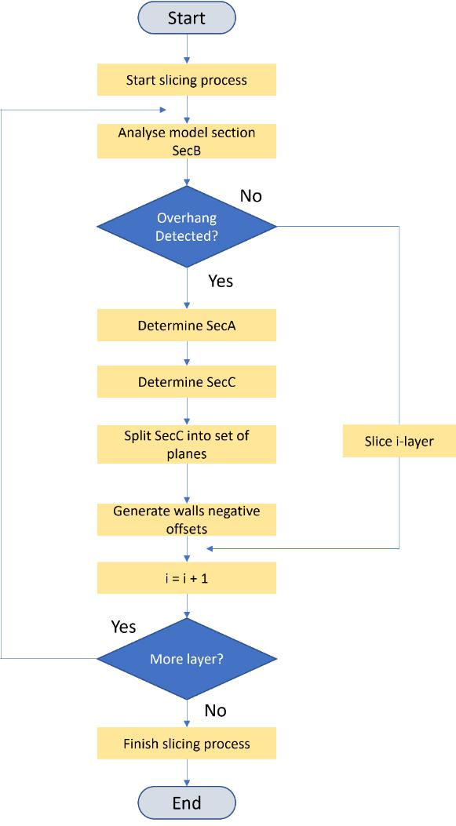

Figure . Algorithm flowchart



Figure 2. SecA Figure 3. SecB



Figure 4. Polyline difference between secA and secB Figure 5. Polylines sub surfaces

## Software development

In order to achieve the objectives of this project, couple of softwares have been used. FullControl Gcode Designer has been used to generate a specific toolpath to print the model, which can help to apply the proposed algorithm. As well as the Repetier-Host software to simulate the generated Gcode and detected any miscalculation in the file before sending it to the printer.

## Experimental Method

To test the algorithm and obtain results between printing overhang structures with/without support, several planar structures will be considered to test the algorithm on them. The test was done three times. The first one, printing support-free overhang using the algorithm, the second, is printing overhang using support, while the test is printing the overhang model without using support.

# Experimental Results

In this section, the results of the experiments will be discussed. The printing time, the amount of wasted plastic, and the post-processing results will be shown. To validate the proposed algorithm, a Rectangular 90° Overhang, Bridge, and T-shape models were tested. The layer height was set at a constant value of 0.2 mm, while the feed rate was set to be 30 mm/minute at the overhang part, and the cooling fan is set at its maximum speed of 100 % duty cycle, acceleration, and jerk, were automatically set by the slicer. The result obtained from printing on-air, printing using support, and printing without support is shown in Figure 7.

## Rectangular 90° Overhang

The printed models are shown in Figure ‎7, where the effectiveness of the algorithm is visually signified. The dimensions of the models are given in Figure 6.

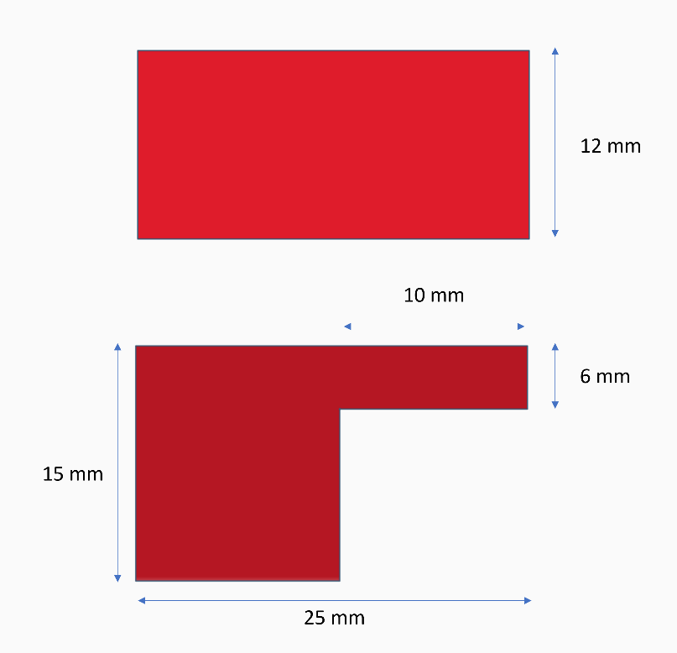

Figure 6. Dimension of Rectangular 90° Overhang structure

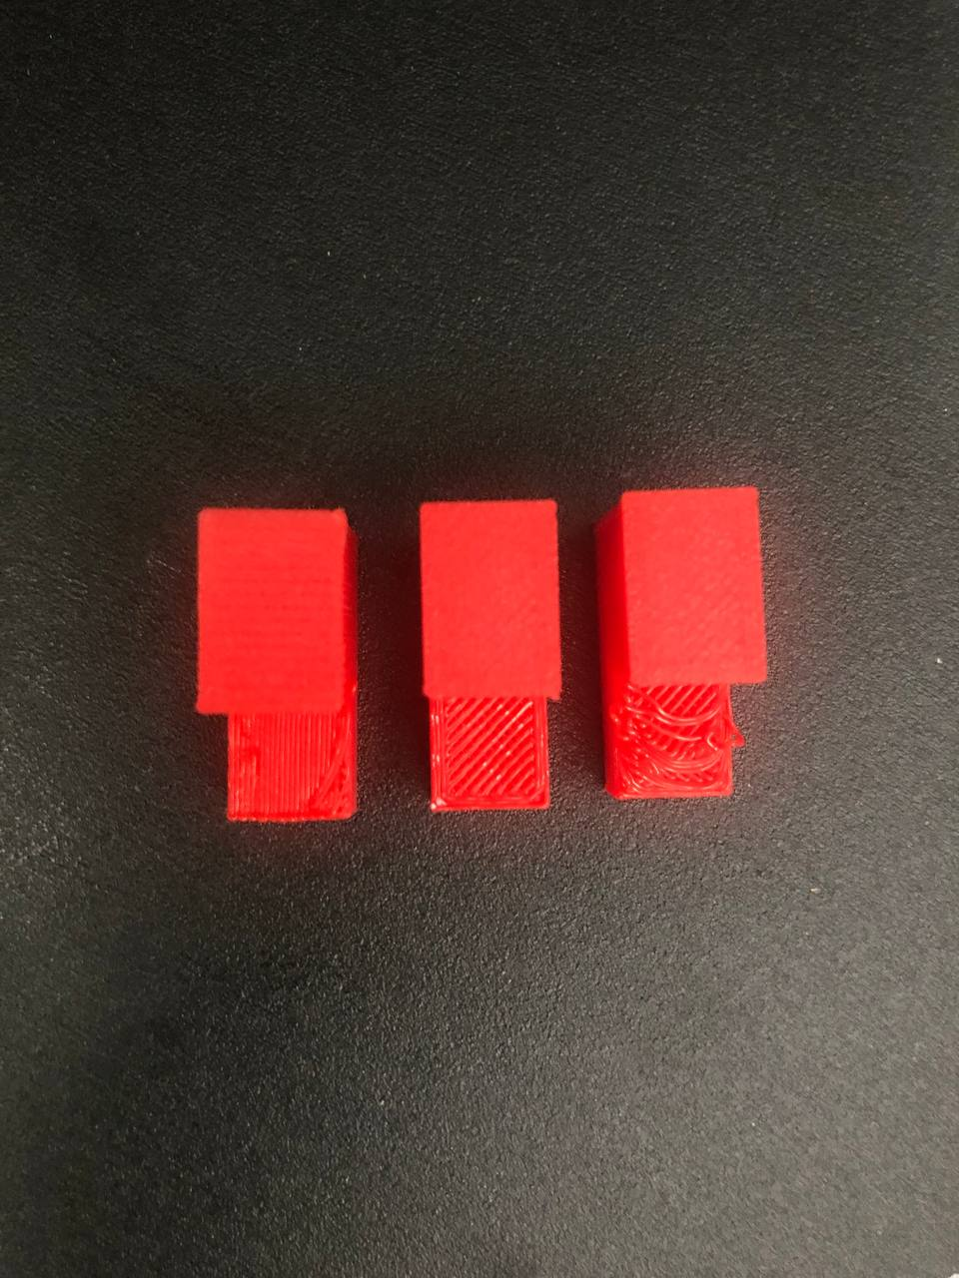

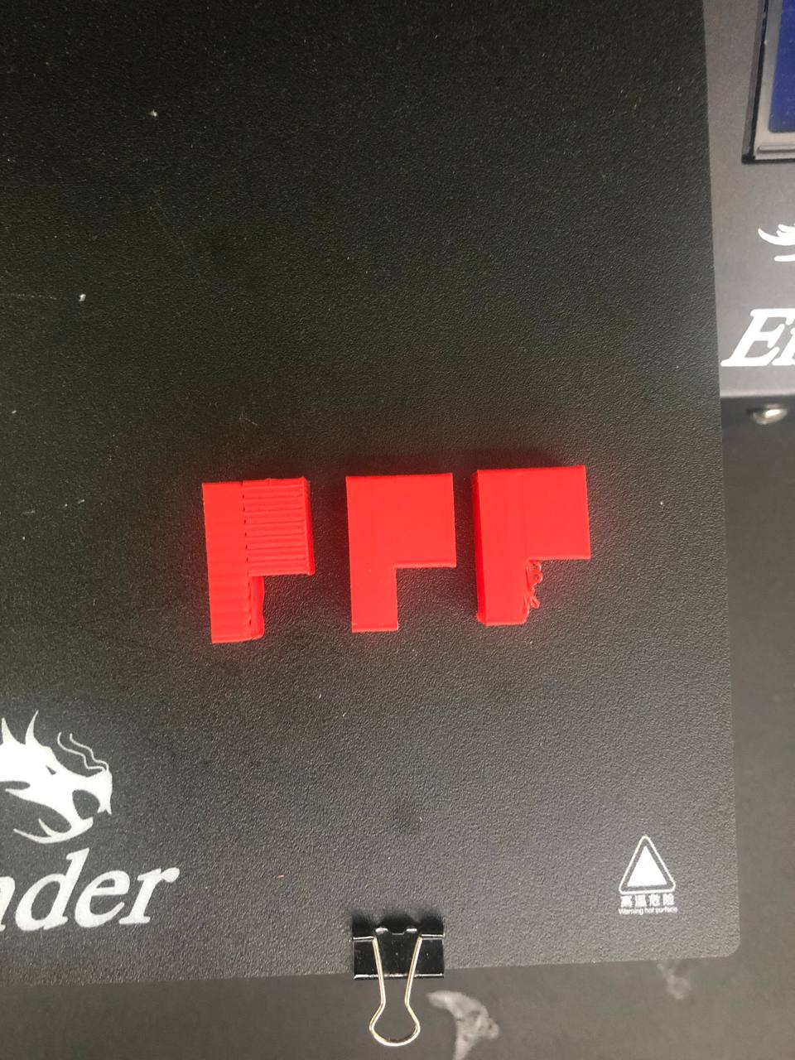

Figure 7. Rectangular 90° Overhang structure (left to right): Print on Air (PoA), supports, supportless

Table ‎1 shows the measurement results of printing the models. Three factors are considered to test the models, the time taken for printing the model, the wasted material, and post-processing for printing on air, with support, and without support.

Table . Results for rectangular 90° overhang model

|  |  |  |  |
| --- | --- | --- | --- |
| **Feature** | **Print on air** | **Support** | **No support** |
| Time (hh:mm) | 00:33 | 00:41 | 00:34 |
| Wasted plastic (g) | 0 | ≈ 2 | 0 |
| Post processing | No | Yes, difficult | No |
| Deformation | No | No | Yes |

## Bridge Model

The Bridge model is shown in Figure 9, it is clear that the print on air achieved better results compared to support-less print. The dimensions of the model are given in Figure 8.

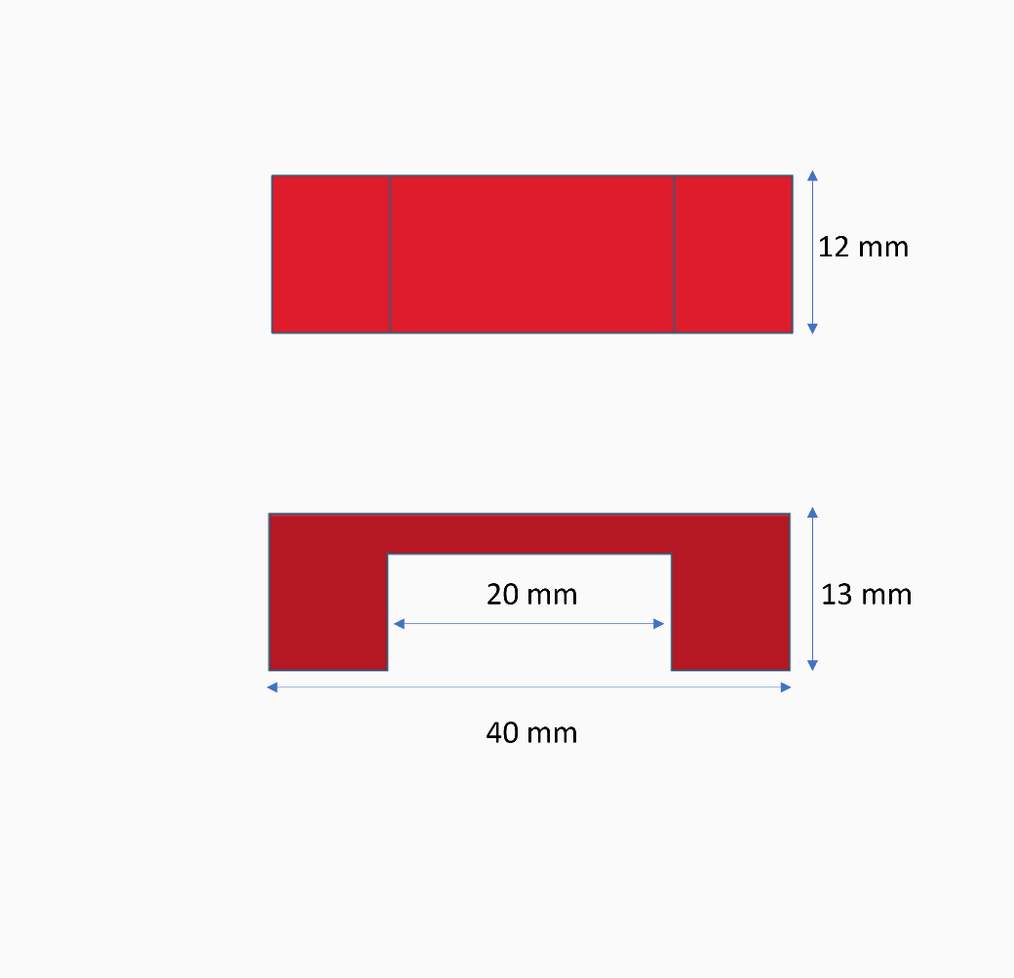

Figure 8. Dimension of bridge model

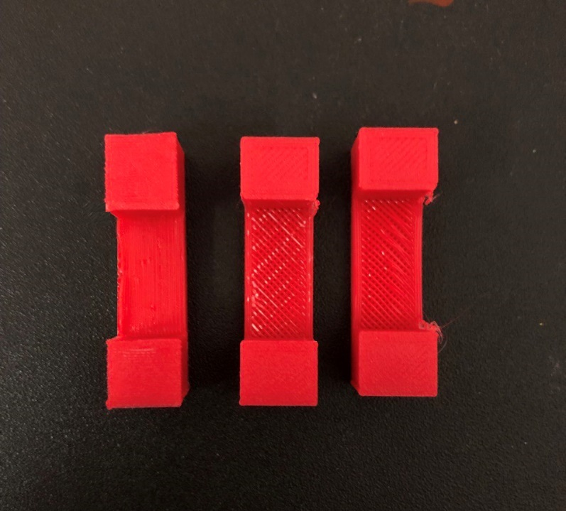

Figure 9. Bridge structure (left to right): Print on Air (PoA), supports, supportless

Table ‎2 shows the results of printing the models. Printing on air took less time than printing with support. Moreover, printing with support caused 2 grams of wasted material and it was difficult to remove it. The support-less print has a deformation under the overhang area.

Table 2. Results for Bridge structure model

|  |  |  |  |
| --- | --- | --- | --- |
| **Feature** | **Print on air** | **Support** | **No support** |
| Time (hh:mm) | 00:39 | 00:46 | 00:38 |
| Wasted plastic (g) | 0 | ≈ 2 | 0 |
| Post processing | No | Yes, difficult | No |
| Deformation | No | No | Yes |

## T-Shape

The T-shape model is shown in Figure 11, print on air shows better result than support-less print. The dimensions of the model are given in Figure 10.

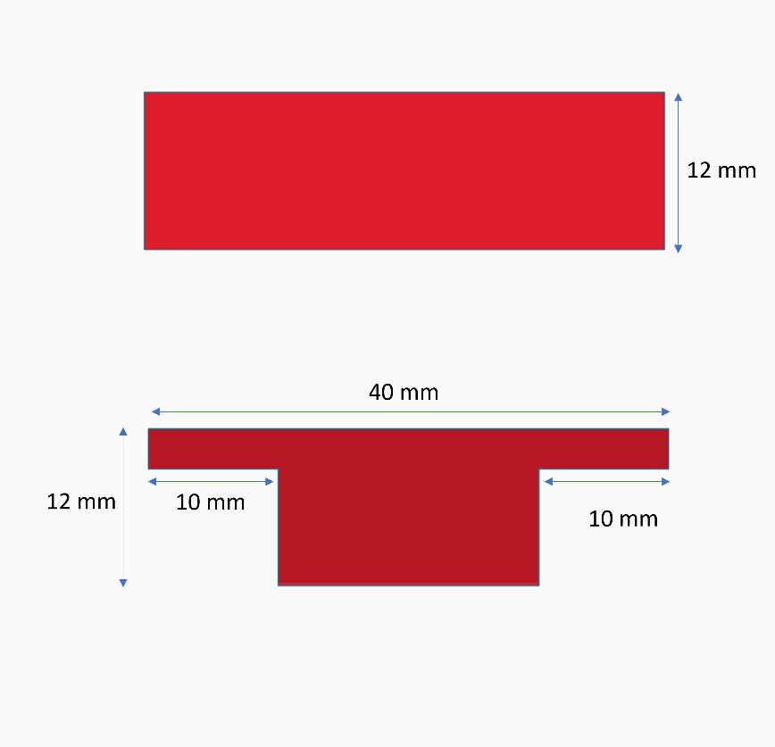

Figure 10. Dimension of T-shape model

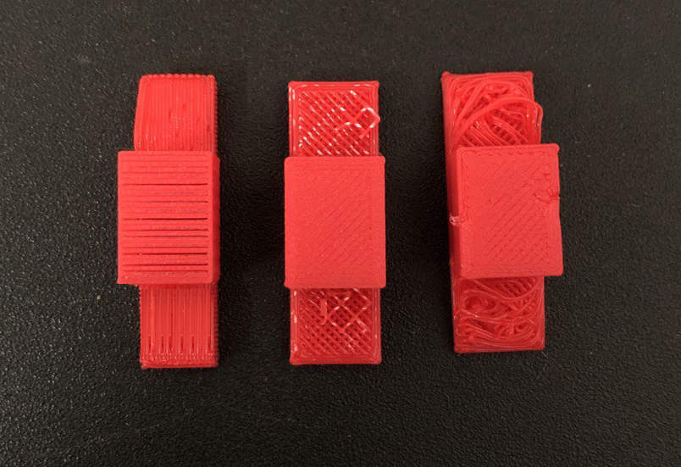

Figure 11. T-shape structure (left to right): Print on Air (PoA), supports, supportless

Table 3 shows the results of printing the models. Printing on air achieved better results in. terms of printing time and use of material without deformation.

Table 3. Results for T-shape model

|  |  |  |  |
| --- | --- | --- | --- |
| **Feature** | **Print on air** | **Support** | **No support** |
| Time (hh:mm) | 00:32 | 00:41 | 00:31 |
| Wasted plastic (g) | 0 | ≈ 4 | 0 |
| Post processing | No | Yes, difficult | No |
| Deformation | No | No | Yes |

## Discussion

Based on the observed result of applying the algorithm to three different overhang structures, the proposed algorithm succeeds to achieve the objective of printing overhang structures without using support. For each overhang model, printing on air was significantly better, and the time spent on printing was shorter than printing with supports. Moreover, the final shape of the model was accurate with no deformation compared to support-less print. In addition, the post-processing of support print was extremely difficult, and it required some tools to remove the support part which led to some damage to the actual model.

# Conclusion

This study was implemented to develop an algorithm to make support-free fused deposition modelling printing for overhang structures. The objectives of this study are achieved and explained in this thesis. The first objective was drawn by applying the developed algorithm to three different overhang structures. Each structure has an overhang angle of 90 degrees. Rectangle overhang, bridge model, and T-shape model were tested. The algorithm was applied to the models using FullControl GCode Designer. The measurement results were obtained from Cura slicer software. Secondly, each model that was printed using the algorithm shows better results in terms of time spent on printing and saving material without affecting the final shape of the actual model.

For future work, the proposed algorithm may be tested on non-planer models to test its efficiency even more. Moreover, other types of printing materials should be tested to confirm the validity of the algorithm on other materials as well. Additionally, to obtain better results it is recommended to add an extra cooling fan along with the extruder to help solidify the overhang print faster and avoid collapse.

# Acknowledgement

This research has been carried out under the Malaysian Technical University Network (MTUN) Research Grant by the Ministry of Higher Education of Malaysia (MOHE) (RDU192816 / UIC190822).

# References

[1] Kanada, Y. (2015). *3D-Printing Plates without “Support”.* International Journal of Computer, Control, Quantum and Information Engineering, WASET, Vol. 9

[2] Melnikova, R., Ehrmann, A., & Finsterbusch, K. (2014). *3D printing of textile-based structures by Fused Deposition Modelling (FDM) with different polymer materials*. *IOP Conference Series: Materials Science and Engineering*, *62*(1). https://doi.org/10.1088/1757-899X/62/1/012018

[3] Mirzendehdel, A. M., & Suresh, K. (2016). *Support structure constrained topology optimization for additive manufacturing.* *CAD Computer Aided Design*, *81*, 1–13. https://doi.org/10.1016/j.cad.2016.08.006

[4] Padhye, N., Kalia, S., & Deb, K. (2009). *Multi-Objective Optimization and Multi-Criteria Decision Making For FDM Using Evolutionary Approaches*. http://home.iitk.ac.in/

[5] Sanyal, S., Musgraves, T., & Vora, H. D. (2018). *Metrology for additive manufacturing (3D printing) technologies*. International Journal of Additive and Subtractive Materials Manufacturing, 2(1), 74. https://doi.org/10.1504/ijasmm.2018.10014605

[6] Shen, Z.-H., Dai, N., Li, D.-W., & Wu, C.-Y. (2016). *Bridge support structure generation for 3D printing*. 141–149. https://doi.org/10.1142/9789813109384_0016

[7] Wei, X., Qiu, S., Zhu, L., Feng, R., Tian, Y., Xi, J., & Zheng, Y. (2018). Toward Support-Free 3D Printing: A Skeletal Approach for Partitioning Models. IEEE Transactions on Visualization and Computer Graphics, 24(10), 2799–2812. https://doi.org/10.1109/TVCG.2017.2767047

[8] Ishak, I. B. & Larochelle, P. (2019): MotoMaker: a robot FDM platform for multi-plane and 3D lattice structure printing, Mechanics Based Design of Structures and Machines, https://doi.org/10.1080/15397734.2019.1615943

[9] Xinhua, L., Shengpeng, L., Zhou, L., Xianhua, Z., Xiaohu, C., & Zhongbin, W. (2015). *An investigation on distortion of PLA thin-plate part in the FDM process.* International Journal of Advanced Manufacturing Technology, 79(5–8), 1117–1126. https://doi.org/10.1007/s00170-015-6893-9

[10] Gleadall, A. (2021). *FullControl GCode Designer: Open-source software for unconstrained design in additive manufacturing*. Additive Manufacturing, 46. https://doi.org/10.1016/j.addma.2021.102109

[11] Vanek, J., Galicia, J. A. G., & Benes, B. (2014). *Clever support: Efficient support structure generation for digital fabrication*. Eurographics Symposium on Geometry Processing, 33(5), 117–125. https://doi.org/10.1111/cgf.12437

[12] Luo, L., Baran, I., Rusinkiewicz, S., & Matusik. W. (2012). *Chopper: partitioning models into 3D-printable parts*. ACM Trans. Graph. 31(6), https://doi.org/10.1145/2366145.2366148

[13] Wang, W., Wang, T. Y., Yang, Z., Liu, L., Tong, X., Tong, W., Deng, J., Chen, F., & Liu, X. (2013). *Cost-effective Printing of 3D Objects with Skin-Frame Structures*. ACM Trans. Graph. 32(6). https://doi.org/10.1145/2508363.2508382