Layout guide for JMES journal using Microsoft Word (Sentence case)
Author 1¹*, Author 2², Author³ (if all authors have same affiliation, don’t put ¹)
¹ Department of Mechanical Engineering, Harcourt Butler Technical University, East Campus, Nawabganj, Kanpur 208002, Uttar Pradesh, India
Phone: +xxxxx, Fax.: +xxxxxx
All affiliations should be indicated with a lower-case or roman number as a superscript letter directly after the author's name and in front of the corresponding address. Please provide the complete postal address of each affiliation (with the country name)
ABSTRACT - The abstract must be concise and informative (maximum 250 words). It should include the aim of the study, a brief description of the methodology, the key findings, and the main conclusions. The abstract should be self-contained, providing sufficient context to stand alone without reference to the main text. References, tables, and figures must not be cited in the abstract. Non-standard or uncommon abbreviations should be avoided; however, if essential, they must be defined upon their first appearance in the abstract. |  | ARTICLE HISTORY
 |  | Received | : | #
 |  | Revised | : | #
 |  | Accepted | : | #
 |  | Published | : | #
 |  | KEYWORDS
 |  | Keyword 1
 |  | Keyword 2
 |  | Keyword 3
 |  | (not more than 6)

1. Introduction
This section should provide adequate background and context for the study, explaining its significance and indicating why it should be of interest to researchers. Avoid an extensive literature review or a detailed summary of the results. The objectives of the study should be stated clearly at the end of this section.

1.1 Sub-Section Headings
Sub-section headings should be written in lower case with initials capitalised and numbered as 1.1, 1.2, etc. Authors should define all abbreviations when they first appear in the text. A list of abbreviations may also be included at the end of the manuscript.
It is strongly recommended that authors use the International System of Units (SI). If other units are referenced, their SI equivalents must be provided.
The manuscript must be written in clear and proper English. Authors are responsible for proofreading their manuscripts for spelling and grammatical accuracy. Manuscripts that are incomplete or poorly written will be returned for revision.
All submissions will be screened for plagiarism using Turnitin software as part of the editorial process.

2. MaterialS and Methods
This section should provide sufficient details to allow the work to be reproduced. Methods previously published should be properly cited, and only relevant modifications need to be described.
Tables should be self-explanatory and include concise captions placed above the table. Tables should be numbered consecutively using Arabic numerals and referred to in the text by number.
Tables must be included within the main text near their first mention and submitted as editable text, not as images. Footnotes may be used to explain abbreviations but should not contain detailed experimental descriptions.
Table 1. Table caption (no period at the end of the caption)
Column number 1 | Column number 2 | Column number 3
Parameter 1 (N) | 12.3 | 1.5
Parameter 2 (kg) | 34.50 | 12.00
Parameter 3 (mm) | 25 | 9

Equations should be written using the Microsoft Equation Editor (Cambria Math, font size 10, justified format).
$$X_{best}\left(t\right)=\min_{i∈1,….,n}{{fit}_{i}(X\left(t\right))}$$ | (1)

Figures should be self-explanatory and include concise yet detailed captions. Acceptable formats include PNG, EPS, TIFF, JPEG, and BMP, with a resolution of 600 dpi for grayscale and 300 dpi for colour.
All figures must be numbered sequentially in the order they appear in the text (e.g., Figure 1, Figure 2). Multi-part figures should be labelled (e.g., Figure 1(a), Figure 1(b)).
Captions should be written in sentence case, placed below the image, centre-aligned, and without a period at the end.
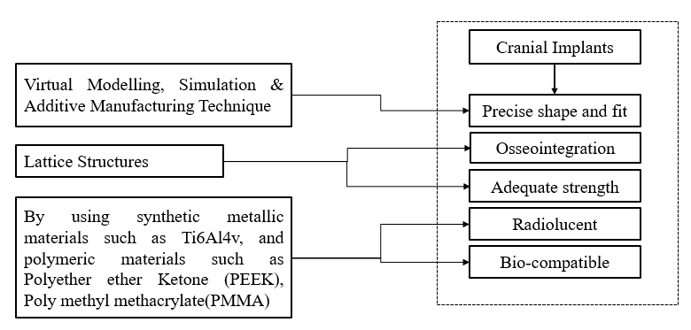
Figure 1. Figure caption (no period at the end of the caption)
Source codes or algorithms should be presented in Courier New, font size 9, justified format.

if rand < Jr
then
apply COOBL
else
check stopping condition
else

This section should also describe the research design, sampling strategy, and data collection methods (if applicable).

3. Results And Discussion
The Results and Discussion sections may be combined. Results should be presented clearly and concisely. The discussion should interpret the findings and explain their significance in relation to existing work. Avoid excessive citations and repetition of previously published material..

4. Conclusions
Provide a brief summary highlighting the key findings and main contributions of the study.

Acknowledgements
This section should acknowledge funding sources and any individuals or organisations that contributed to the research but do not meet the authorship criteria. Ensure that all individuals named in this section have consented to be acknowledged.
List funding sources in the following standard format to comply with the funder requirements:

Funding
- This work was supported by the name of funding sources including the type of grant and reference number [grant numbers …]. Detailed descriptions of the programme or grants and awards are not required.
- The following statement should be included if there is no funding available for the research:
- This study was not supported by any grants from funding bodies in the public, private, or not-for-profit sectors.

Conflict Of Interest
Authors must disclose any financial or non-financial interests that could be perceived to influence the work reported in this manuscript. These may include political, personal, or professional relationships that could potentially bias the research outcomes.
If no potential conflicts exist, the authors should include the following statement:
The authors declare no conflicts of interest.

Authors’ Contribution
Authors are encouraged to include an author statement detailing their specific roles in the preparation of the manuscript, in accordance with the journal’s authorship policy. The corresponding author must ensure that all authors agree with the accuracy of their contributions.
The following standard roles are recommended:
Conceptualisation; Methodology; Validation; Formal analysis; Data curation; Investigation; Resources; Software; Visualisation; Writing – original draft; Writing – review & editing; Funding acquisition; Project administration; Supervision.
Example format:
M.M. Rahman (Conceptualisation; Formal analysis; Visualisation; Supervision)
W.T. Urmi (Methodology; Data curation; Writing – original draft; Resources)

AVAILABILITY OF DATA AND MATERIALS
Authors should provide a clear statement regarding the accessibility of the data, materials, and code used in the study to promote transparency and reproducibility. Examples include:
- Available on request:
The datasets generated and/or analysed during the current study are available from the corresponding author on reasonable request.
- Publicly available:
The datasets generated during and/or analysed during the current study are available in the [repository name] at [persistent link/DOI].
- Not applicable:
Data sharing is not applicable to this article as no new data were created or analysed in this study.

ETHICS STATEMENT
An ethics statement must be provided if the study involves human participants, animal subjects, or sensitive data. Authors must ensure compliance with institutional, national, and international ethical standards.
Examples:
- For human data or participation:
The study was conducted in accordance with the Declaration of Helsinki and approved by the [name of ethics committee] (Approval No. [XXXX]). Informed consent was obtained from all participants involved in the study.
- For animal studies:
All experimental procedures involving animals were approved by the [Institutional Animal Care and Use Committee name] (Approval No. [XXXX]) and conducted in accordance with relevant guidelines and regulations.
- For simulation or secondary data studies:
This study did not involve human participants or animals. Ethical approval was therefore not required.

References
- Relevant and up-to-date references must be included in the text. All references in the text should be numbered sequentially [in square brackets], and all references in the reference section should be presented in the same numerical sequence. Within the square brackets, several citations should be separated by commas to avoid confusion. It is necessary to provide ranges in the situation of more than two sequential references.
- Reference citations should not be included in the title, headers, or abstract of the paper. It is suggested that the reference list be formatted solely in accordance with the IEEE style (numeric). The names of all authors should be included if there are six or fewer authors in the reference. It is typical to list the first three authors, followed by the phrase "et al." when there are seven or more authors.
- Citation manipulation refers to the excessive citation of an author's study (i.e., self-citation by authors) for the sole purpose of boosting the number of citations of the author's work (COPE, 2019). JMES journal encourage authors to restrict self-citation to a minimum to control citation manipulation. JMES journal highly advises using no more than 5 (including jointly authored publications) or 10 per cent self-citations, whichever is lower, in any given publication.

