Layout guide for JMES journal using Microsoft Word (Sentence case or Title Case)
Author 1¹*, Author 2², Author³ (if all authors have same affiliation, don’t put ¹)
¹ Department of Mechanical Engineering, Harcourt Butler Technical University, East Campus, Nawabganj, Kanpur 208002, Uttar Pradesh, India
Phone: +xxxxx, Fax.: +xxxxxx
All affiliations should be indicated with a lower-case or roman number as a superscript letter directly after the author's name and in front of the corresponding address. Please provide the complete postal address of each affiliation (with the country name)
ABSTRACT - It is important to write a concise and informative abstract (maximum 250 words). The aim of the study, the brief methodology, the main findings, and the major conclusions should all be included in the abstract. For an abstract to be effective, it must be stand-alone and self-explanatory. References, tables, and figures should not be cited in the abstract. Additionally, non-standard or unusual abbreviations should be avoided; nevertheless, if they are necessary, they must be explained at the time of their first mention in the abstract text. |  | ARTICLE HISTORY
 |  | Received | : | #
 |  | Revised | : | #
 |  | Accepted | : | #
 |  | Published | : | #
 |  | KEYWORDS
 |  | Keyword 1
 |  | Keyword 2
 |  | Keyword 3
 |  | (not more than 6)

1.0 INTRODUCTION

This should provide an adequate background and general context for the work, explaining its significance, and indicating why it should be of interest to researchers. Avoiding a detailed literature survey or a summary of the results. State the objectives of the study at the end of this section.

1.1 Sub-Section Headings
Sub-section headings, however, should be in lower-case with their initials capitalised. They should be numbered as 1.1, 1.2, etc.
The author (s) should define all abbreviations used when the first time appeared in the text. A list of abbreviations may also be included at the end.
It is strongly recommended that the author (s) should use the International System of Units (SI) units. If other quantities are referenced, please provide their SI equivalents.
The manuscript should be written in the English language clearly and understandably. The manuscript should be proofread for proper spelling and grammar use. We shall promptly return any manuscripts that are not complete or are not in good condition.
A well-established component of the editorial process is plagiarism screening. Turnitin software will be used to verify all submitted manuscripts for plagiarism check.

2.0 METHODS AND MATERIAL
It is recommended that the authors provide adequate information to enable the work to be replicated. Methods that have previously been published should be referenced, and only relevant modifications should be mentioned.
Figures should be self-explanatory and contain a short but adequately detailed caption. Figures should be provided in one of the following formats: PNG, EPS, TIFF, JPEG, BMP. The figure(s) should have a resolution of 600 dpi for grayscale and 300 dpi for colour. All figures must be numbered sequentially in the text in the same order in which they appear (e.g. Figure 1, Figure 2). Figure 1(a) and Figure 1(b) are examples of multi-part figures in which each component should be labelled. The figure(s) caption should be written in sentence cases and placed underneath the image, centre aligned, with no period at the end of the caption.
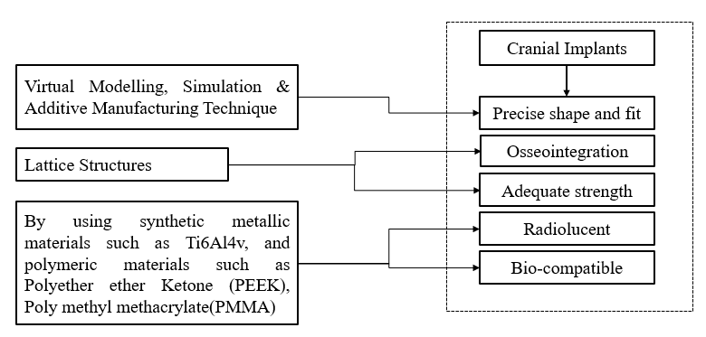
Figure 1. Figure caption (no period at the end of the caption)
Tables should be self-explanatory and include a concise yet sufficiently descriptive caption. Tables should be numbered consecutively using Arabic numerals and referred to in the text by number. Table legends should follow the main text, each on a separate page. Tables must be submitted as editable text and not as images. Footnotes can be used to explain abbreviations but should not include detailed descriptions of the experiment.
Table 1. Table caption (no period at the end of the caption)
Column number 1 | Column number 2 | Column number 3
Parameter 1 (N) | 12.3 | 1.5
Parameter 2 (kg) | 34.50 | 12.00
Parameter 3 (mm) | 25 | 9
Equation should be presented by using the Microsoft equation of Cambria Math (or MathType) font 10 in justify format.
$$X_{best}\left(t\right)=\min_{i∈1,….,n}{{fit}_{i}(X\left(t\right))}$$ | (1)
Any source: coding or algorithm will be presented as the Courier New font of size 9 in justify format.
if rand < Jr
then
apply COOBL
else
check stopping condition
else
This section must describe the methodology in detail: research design, sampling, data collection (if necessary).

3.0 RESULTS AND DISCUSSION
It is appropriate to combine the Results and Discussion sections into a single section. Clear and concise results are required. The significance of the work's findings should be discussed in detail throughout the discussion section. Extensive citations and discussion of already published material should be avoided.

4.0 CONCLUSIONS
A brief paragraph summarising all the significant accomplishments achieved.

5.0 CONFLICT OF INTEREST
It should disclose any financial or non-financial interests such as political, personal, or professional relationships that may be interpreted as having influenced the manuscript. The phrase "The authors declare no conflicts of interest" should be included if there is no conflict of interest.

6.0 AUTHORS CONTRIBUTION
Authors are encouraged to provide an author statement file describing their specific contributions to the article using the appropriate author contribution roles to increase transparency. The corresponding author is responsible for ensuring that all authors agree on the accuracy of the descriptions. All authors' roles should be mentioned, using the appropriate categories underneath. Authors may have played a variety of roles in their contributions. Contributions from authors do not affect the criteria for authorship established by the journal. The following are the words used to describe author contributions.
Conceptualisation; Methodology; Validation; Formal analysis; Data curation; Formal analysis; Investigation; Resources; Software; Visualisation; Writing - original draft; Writing - review & editing; Funding acquisition; Project administration; Supervision.
Authorship statements should be formatted with the names of authors first and the author contribution role(s) following, such as
M.M. Rahman (Conceptualization; Formal analysis; Visualisation; Supervision)
W.T. Urmi (Methodology; Data curation; Writing - original draft; Resources)

7.0 ACKNOWLEDGEMENTS
This section should describe sources of funding that have supported the work. Please also describe the role of the study sponsor(s) (if any) in study design; collection, analysis, and interpretation of data writing of the paper and decision to submit it for publication. Recognition of personal assistance should be given as a separate paragraph: people who contributed to the work, but do not fit the criteria for authors should be listed along with their contributions. You must ensure that anyone named in the acknowledgments agrees to being so named.
Formatting of funding sources: List funding sources in this standard way to facilitate compliance to funder's requirements:
Funding
- This work was supported by the name of funding sources including the type of grant and reference number [grant numbers …]. Detailed descriptions of the programme or grants and awards are not required.
- The following statement should be included if there is no funding available for the research:
This study was not supported by any grants from funding bodies in the public, private, or not-for-profit sectors.

8.0 REFERENCES
- Relevant and up-to-date references must be included in the text. All references in the text should be numbered sequentially [in square brackets], and all references in the reference section should be presented in the same numerical sequence. Within the square brackets, several citations should be separated by commas to avoid confusion. It is necessary to provide ranges in the situation of more than two sequential references.
- Reference citations should not be included in the title, headers, or abstract of the paper. It is suggested that the reference list be formatted solely in accordance with the Vancouver Style. The names of all authors should be included if there are six or fewer authors in the reference. It is typical to list the first three authors, followed by the phrase "et al." when there are seven or more authors.
- Citation manipulation refers to the excessive citation of an author's study (i.e., self-citation by authors) for the sole purpose of boosting the number of citations of the author's work (COPE, 2019). JMES journal encourage authors to restrict self-citation to a minimum to control citation manipulation. JMES journal highly advises using no more than 5 (including jointly authored publications) or 10 per cent self-citations, whichever is lower, in any given publication.

