Parametric analysis of a divided rocker for battery electric vehicles
Haseeb Shafaqat¹*, Christopher Krüger², Peter Urban³
¹Department of Mechanical Engineering, Harcourt Butler Technical University, East Campus, Nawabganj, Kanpur 208002,
Uttar Pradesh, India
Please provide the complete postal address of each affiliation (with the country name)
ABSTRACT - It is important to write a concise and informative abstract (maximum 250 words). The aim of the study, the brief methodology, the main findings, and the major conclusions should all be included in the abstract. For an abstract to be effective, it must be stand-alone and self-explanatory. References, tables, and figures should not be cited in the abstract. Additionally, non-standard or unusual abbreviations should be avoided; nevertheless, if they are necessary, they must be explained at the time of their first mention in the abstract text. |  | ARTICLE HISTORY
 |  | Received | : | 13-10- 2022
 |  | Revised | : | 24-11- 2022
 |  | Accepted | : | 002-03-2023
 |  | Published | : | 30-03- 2023
 |  | KEYWORDS
 |  | Keyword 1
 |  | Keyword 2
 |  | Keyword 3
 |  | *(not more than 6)

1. INTRODUCTION
This should provide an adequate background and general context for the work, explaining its significance, and indicating why it should be of interest to researchers. Avoiding a detailed literature survey or a summary of the results. State the objectives of the study at the end of this section.

1.1 Sub-Section Headings
Sub-section headings, however, should be in lower-case and italicised with their initials capitalised. They should be numbered as 1.1, 1.2, etc.

1.1.1 Sub-section headings
The author (s) should define all abbreviations used when the first time appeared in the text. A list of abbreviations may also be included at the end.
It is strongly recommended that the author (s) should use the International System of Units (SI) units. If other quantities are referenced, please provide their SI equivalents.
The manuscript should be written in the English language clearly and understandably. The manuscript should be proofread for proper spelling and grammar use. We shall promptly return any manuscripts that are not complete or are not in good condition.
A well-established component of the editorial process is plagiarism screening. Turnitin software will be used to verify all submitted manuscripts for plagiarism check.

2. LITERATURE REVIEW
It is recommended that the authors provide adequate information to enable the work to be replicated.

3. METHODS and materials
Methods that have previously been published should be referenced, and only relevant modifications should be mentioned.
Figures should be self-explanatory and contain a short but adequately detailed caption. Figures should be provided in one of the following formats: PNG, EPS, TIFF, JPEG, BMP. The figure(s) should have a resolution of 600 dpi for grayscale and 300 dpi for colour. All figures must be numbered sequentially in the text in the same order in which they appear (e.g. Figure 1, Figure 2). Figure 1(a) and Figure 1(b) are examples of multi-part figures in which each component should be labelled. The figure(s) caption should be written in sentence cases and placed underneath the image, centre aligned, with no period at the end of the caption.
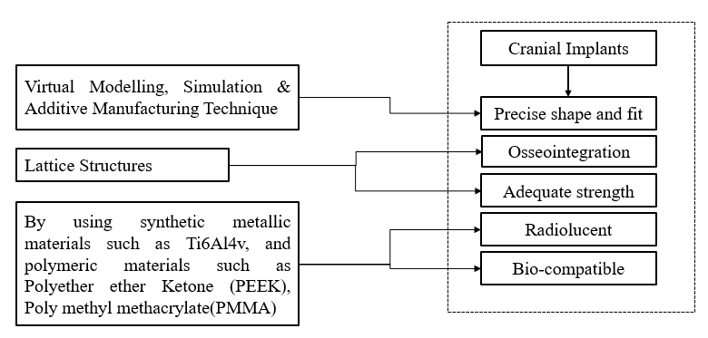
Figure 1. Figure caption
Tables should be self-explanatory and include a concise yet sufficiently descriptive caption. Tables should be numbered consecutively using Arabic numerals and referred to in the text by number. Table legends should follow the main text, each on a separate page. Tables must be submitted as editable text and not as images. Footnotes can be used to explain abbreviations but should not include detailed descriptions of the experiment.
Table 1. Table caption
Column number 1 | Column number 2 | Column number 3
Parameter 1 (N) | 12.3 | 1.5
Parameter 2 (kg) | 34.5 | 12.0
Parameter 3 (mm) | 25 | 9
Equation should be presented by using the Microsoft equation of Cambria Math (or MathType) font 10 in justify format.
$$X_{best}\left(t\right)={fit}_{i}(X\left(t\right))$$ | (1)
Any source: coding or algorithm will be presented as the Courier New font of size 9 in justify format.
if rand < Jr
then
apply COOBL
else
check stopping condition
else
This section must describe the methodology in detail: research design, sampling, data collection (if necessary).

4. RESULTS AND DISCUSSION
It is appropriate to combine the Results and Discussion sections into a single section. Clear and concise results are required. The significance of the work's findings should be discussed in detail throughout the discussion section. Extensive citations and discussion of already published material should be avoided.

5. CONCLUSIONS
A conclusion section must be included and should indicate clearly the advantages, limitations and possible applications of the paper. Discuss about future work. Do not cite references in this section

ACKNOWLEDGEMENT
The researchers would like to acknowledge Universiti ….. for supporting this project.

FUNDING STATEMENT
This section should describe sources of funding that have supported the work. Please also describe the role of the study sponsor(s) (if any) in study design; collection, analysis, and interpretation of data writing of the paper and decision to submit it for publication. Recognition of personal assistance should be given as a separate paragraph: people who contributed to the work, but do not fit the criteria for authors should be listed along with their contributions. You must ensure that anyone named in the acknowledgments agrees to being so named.
Formatting of funding sources: List funding sources in this standard way to facilitate compliance to funder's requirements:
No funding: This study was not supported by any grants from funding bodies in the public, private, or not-for-profit sectors.
(Example 1)
The authors would like to thank the Sumatera Institut of Technology (ITERA), Indonesia for providing the necessary resources and equipment for this research. This study was not supported by any grants from funding bodies in the public, private, or not-for-profit sectors.
(Example 2)
The authors would like to thank Universiti Teknologi PETRONAS (UTP), Institute of Smart & Sustainable Living (ISSL), and Centre of Smart Infrastructure Modelling & Monitoring (SIMM) for their support in this research. This work was supported by a research grant from TotalEnergies EP Malaysia allocated under the cost centre 015MD0-163.

AUTHORS CONTRIBUTION
Authors are encouraged to provide an author statement file describing their specific contributions to the article using the appropriate author contribution roles to increase transparency. The corresponding author is responsible for ensuring that all authors agree on the accuracy of the descriptions. All authors' roles should be mentioned, using the appropriate categories underneath. Authors may have played a variety of roles in their contributions. Contributions from authors do not affect the criteria for authorship established by the journal. The following are the words used to describe author contributions.
Conceptualisation; Methodology; Validation; Formal analysis; Data curation; Formal analysis; Investigation; Resources; Software; Visualisation; Writing - original draft; Writing - review & editing; Funding acquisition; Project administration; Supervision.
Authorship statements should be formatted with the names of authors first and the author contribution role(s) following, such as;
M.M. Rahman (Conceptualization; Formal analysis; Visualisation; Supervision)
W.T. Urmi (Methodology; Data curation; Writing - original draft; Resources)

AVAILABILITY OF DATA AND MATERIALS
The data supporting this study’s findings are available on request from the corresponding author.

ETHICAL STATEMENT
Not applicable.

CONFLICT OF INTEREST
It should disclose any financial or non-financial interests such as political, personal, or professional relationships that may be interpreted as having influenced the manuscript. The phrase "The authors declare no conflicts of interest" should be included if there is no conflict of interest.

REFERENCES
Huang, X., Sun, J., & Sun, J. (2018). A car-following model considering asymmetric driving behavior based on long short-term memory neural networks. Transportation Research Part C: Emerging Technologies, 95(February), 346–362. https://doi.org/10.1016/j.trc.2018.07.022
James, S. L., Abate, D., Abate, K. H., Abay, S. M., Abbafati, C., Abbasi, N., Abbastabar, H., Abd-Allah, F., Abdela, J., Abdelalim, A., Abdollahpour, I., Abdulkader, R. S., Abebe, Z., Abera, S. F., Abil, O. Z., Abraha, H. N., Abu-Raddad, L. J., Abu-Rmeileh, N. M. E., Accrombessi, M. M. K., … Murray, C. J. L. (2018). Global, regional, and national incidence, prevalence, and years lived with disability for 354 diseases and injuries for 195 countries and territories, 1990–2017: a systematic analysis for the Global Burden of Disease Study 2017. The Lancet, 392(10159), 1789–1858. https://doi.org/10.1016/S0140-6736(18)32279-7
Tan, H., Qin, L., Jiang, Z., Wu, Y., & Ran, B. (2018). A hybrid deep learning based traffic flow prediction method and its understanding. Transportation Research Part C: Emerging Technologies, 90(January), 166–180. https://doi.org/10.1016/j.trc.2018.03.001
Taylor, K., Post, A., Hoshizaki, T. B., & Gilchrist, M. D. (2019). The effect of a novel impact management strategy on maximum principal strain for reconstructions of American football concussive events. Proceedings of the Institution of Mechanical Engineers, Part P: Journal of Sports Engineering and Technology, 233(4), 503–513. https://doi.org/10.1177/1754337119857434

