Titles must be formatted in 14-point Times New Roman, using sentence case; only the first word, the first word of any subtitle, and proper nouns should be capitalised without any line spacing
Author¹, Author² and Author³ (If all authors share the same affiliation, omit the superscript numeral (do not use "1"). Indicate the corresponding author with an asterisk (*) placed immediately after their name. Apply line spacing of 6 points before and 6 points after.
¹Department of Mechanical Engineering, Harcourt Butler Technical University, East Campus, Nawabganj, Kanpur 208002, Uttar Pradesh, India
All affiliations should be indicated with a lower-case or roman number as a superscript letter directly after the author's name and in front of the corresponding address. Please provide the complete postal address of each affiliation (with the country name)
Abstract - The abstract must be formatted in 9-point Times New Roman font, with no indentation. Each manuscript must include a self-contained abstract limited to 250 words. Since the abstract is indexed and displayed separately from the main article, it should clearly present the purpose, methodology, key findings, conclusions, and significance, without referencing external figures, tables, or abbreviations. It should highlight the importance of the research problem and the study’s primary goal, provide sufficient detail on the methodology and materials to enable the reader to evaluate the study design, and summarise the most important results, including relevant quantitative data. The abstract should also state the main conclusions and discuss the broader impact or implications. Any new contributions or significant limitations affecting interpretation should be noted. Avoid obscure abbreviations; if needed, define them when first used. |  | Article history
 |  | Received :
 |  | Revised :
 |  | Accepted :
 |  | Published :
 |  | Keywords
 |  | Keyword 1
 |  | Keyword 2
 |  | Keyword 3
 |  | Keyword 4
 |  | Keyword 5
 |  | (Provide 3–6 keywords in italic sentence case that reflect the manuscript's main topics, methods, and discipline)

1. Introduction
The introduction must provide the research background and broader context necessary for readers across the journal's international readership to understand the significance of the work, identify the gap in existing knowledge that the study addresses, and understand why the work is of interest. A brief but focused literature review situating the work within the current state of the art is required; a comprehensive survey of the full field history is not appropriate for the introduction and should be reserved for dedicated review articles. The introduction should not summarise the results or conclusions of the work, which must appear in their designated sections. The research objectives must be stated explicitly and concisely at the close of the introduction. The use of the International System of Units (SI) is strongly recommended; where alternative units are cited, their SI equivalents must be included. Furthermore, manuscripts must be composed in clear, grammatically correct English. Authors bear the primary responsibility for thorough proofreading to ensure linguistic accuracy. As part of our commitment to academic integrity, all manuscripts will undergo plagiarism screening via Turnitin software during the editorial process.

1.1 Sub-Section Headings
Section headings must be numbered consecutively using Arabic numerals, starting with the Introduction as Section 1. All primary headings should be left-aligned, formatted in the Mekatronika Heading 1 style, and capitalised in title case. Secondary headings (second level) should be numbered with two digits (e.g., 2.1, 2.2), formatted in the Mekatronika Heading 2 style, with the first letter capitalised (title case). Tertiary headings (third level) are numbered with three digits (e.g., 2.1.1), formatted in sentence case, and italicised. Avoid headings beyond the third level whenever possible.

2. Materials and Methods
The materials and methods section must provide sufficient detail to enable an independent researcher with relevant expertise to replicate the work. This reproducibility requirement serves as an editorial quality standard. If methods are previously published, they can be referenced instead of fully described; only key modifications to established methods need to be detailed. For experimental procedures, specify materials, instruments, reagents, experimental conditions, control procedures, and measurement uncertainty with adequate precision. For computational work, include all governing equations, boundary and initial conditions, numerical methods, convergence criteria, and software information, including version numbers. Clearly identify and justify all statistical methods used. The methodology should be detailed comprehensively to ensure reproducibility. Previously published methods must be appropriately cited, with only significant modifications requiring description.
2.1 Tables
Submit all tables as editable text (not images) using standard word-processing software. Place a brief, descriptive caption in sentence case directly above each table, with 6 pt spacing above and below. Number tables consecutively with Arabic numerals (Table 1, Table 2) in the order cited. Tables must be self-explanatory. Use footnotes below the table only to define non-standard abbreviations or indicate statistical significance; describe experimental procedures in the Materials and Methods section. Avoid vertical rules and cell shading. Place table legends after the main text, each on a separate page.
Table 1. Table caption (please ensure no period is placed at the end of the caption)
Parameter description | Parameter value 1 | Parameter value 2 | Unit
Parameter 1 | 12.3 | 1.5 | N
Parameter 2 | 34.50 | 12.00 | kg
Parameter 3 | 25 | 9 | mm
2.2 Equations
Submit all equations as editable text using Microsoft Word Equation Editor or MathType, not as images. Use a solidus (X/Y) for simple fractions in running text. Italicise variables, bold vectors and matrices, and set standard functions (log, sin, exp) in Roman type; write powers of e as "exp". Display complex or multi-line equations on separate lines, numbered consecutively with right-aligned Arabic numerals in parentheses (e.g., Eq. (1), Eqs. (2–3)). Appendix equations use the appendix letter as a prefix, such as (Eq. A1, B2). Each equation must be left-aligned with 6-point spacing above and below. Please ensure all symbols and variables are clearly defined upon their first mention in the text. Complex equations should be presented on separate lines to maintain clarity and professionalism.
$$X_{best}\left(t\right)=\min_{i∈1,….,n}{{fit}_{i}(X\left(t\right))}$$ | (1)
2.3 Figures
Submit figures as PNG, EPS, TIFF, JPEG, or BMP (grayscale ≥600 dpi; colour ≥300 dpi). Cite all figures in the text and number them with Arabic numerals in order of appearance (e.g., Figure 1, Figure 2); label multi-panel figures as Figure 1(a), Figure 1(b), etc. Place a brief, descriptive caption in sentence case directly below each figure, without a closing period and with 6-point spacing before and after. Do not duplicate table data. Colour figures appear online, so ensure they remain clear in grayscale for print. Remove all boundary lines so that only the plot area and legend sit within the plot, and make sure every figure and its text are sharp and legible.
Ensure no boundary lines are visible on any figure. Only the plot area and legend should be within the plot boundaries. The figure must be clear, and all text must be legible. Captions must be written in sentence case, positioned below the image, centre-aligned, and should not conclude with a period.
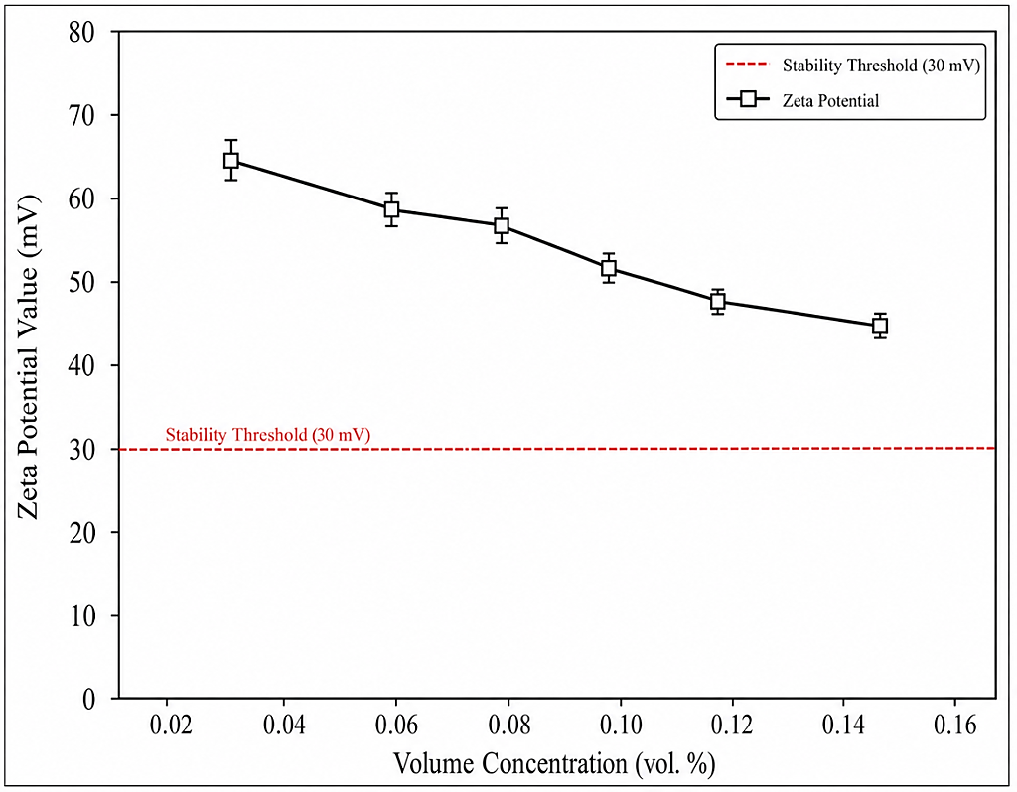
Figure 1. Figure caption (please ensure no period is placed at the end of the caption)
2.4 Algorithms
Source code and algorithms should be formatted in Courier New (9-point font), italic and presented in a justified layout. To ensure clarity, code snippets should be clearly separated from the main text and, where necessary, enclosed within a frame or box. If multiple algorithms are included, they should be numbered consecutively (e.g., Algorithm 1, Algorithm 2) and accompanied by a concise title.

if rand < Jr
then
apply COOBL
else
check stopping condition
else

This section must provide a comprehensive account of the research design, sampling strategy, and data collection procedures. Authors should clearly delineate the rationale behind the chosen methodology and, where applicable, describe the instruments used for data acquisition. To ensure ethical standards, information regarding participant recruitment and ethical approval (if relevant) should also be included. These details are essential to allow for the validation and potential replication of the study by other researchers.
The use of flowcharts or diagrams to illustrate the research process is highly encouraged.
2.5 Abbreviations
All abbreviations should be defined when first introduced in the main text. A list of abbreviations may also be included at the end of the manuscript, after the references. Abbreviations in the abstract must be explained within the abstract itself, even if they are defined in the main text. Authors are strongly encouraged to use SI (International System of Units) units throughout the document. If other unit systems are used for disciplinary standards or to align with cited literature, the SI equivalent must also be provided.

3. Results and Discussion
Results and discussion can be presented either as separate subsections or combined into one, based on what best enhances clarity. Results should be clear and precise, including measures of uncertainty, statistical significance, and replication. The discussion should place the findings within the context of existing literature, highlight their importance, address any discrepancies or unexpected results, and note limitations that affect the scope or generalisability. Avoid excessive citation and re-description of previous work; instead, focus on interpreting and contextualising the new findings.
Sub-headings may be used to structure the discussion into key thematic areas for better readability.

4. Conclusions
The conclusions section should provide a clear, focused summary of the main findings and their significance. It must directly address the goals outlined in the introduction, reaffirm the study's key findings, and discuss the practical and theoretical implications of the results. Instead of just repeating the abstract or listing the results, it should synthesise and interpret the findings in relation to the objectives and the broader field. Authors may also highlight unresolved questions or propose future research directions based on the current study's limitations or scope.

Acknowledgements
The Acknowledgements section should list all individuals who helped with the research or manuscript but do not meet the ICMJE authorship criteria. Contributions must be specified by name and type, such as statistical advice, lab support, or language editing. Each individual’s acknowledgement must be confirmed by them before submission. Funding sources are not to be included here but should be reported in the separate Funding subsection below. Any institutional contributions must also be acknowledged in this section.

Funding
Authors must disclose all financial and material support related to the research and manuscript. This includes grants, fellowships, publication fee assistance, in-kind contributions (e.g., equipment, materials, reagents, data tools), externally funded salaries, and travel or accommodation expenses. The section should be titled “Funding” and list the full official name of each funder, along with the corresponding grant or award number. The same details must be entered into the submission system’s funding metadata fields to ensure inclusion in the CrossMark record and in international funding registries. The corresponding author is responsible for ensuring that all funding disclosures are accurate, complete, and consistent across co-authors prior to submission.
- With Funding: 'This work was supported by [Source of funding body], including the [Type of grant] and [Grant number: xxxxx].' (Note: Detailed descriptions of the programmes, grants, or awards are not required.
- Without Funding: If no specific funding was available for the research, the following mandatory statement must be included: 'This study was not supported by any grants from funding bodies in the public, private, or not-for-profit sectors.'
Declaration of Competing Interests
A competing interest is any financial, professional, personal, or institutional connection that could influence the research. Disclosure ensures transparency, not an admission of bias. Authors must declare all relevant interests from the three years before the research, and any earlier ones that could still be perceived as a bias. Financial interests include employment, stocks or options, consultation fees, honoraria, paid expert testimony, royalties, and related patents in organisations with a stake in the outcome. Non-financial interests include unpaid leadership roles, relevant personal or professional relationships, and strongly held beliefs on the subject. These obligations extend to immediate family members. Authors with editorial or advisory roles at journal must notify the editorial office before submission and include a recusal statement in the Declaration of Competing Interests.
- With competing interests
Specify each author's individual interests clearly using the sub-heading 'Declaration of Competing Interests'.
- No competing interests
The authors declare no conflicts of interest OR
The authors declare no relevant financial or non-financial conflicts of interest OR
All authors certify that they have no affiliations with any organisation with a financial or non-financial interest in the subject matter of this manuscript'

CRediT Author Contribution Statement
The journal requires that every manuscript include a CRediT Author Contribution Statement using the 14 standardised NISO CRediT roles. This statement complements, but does not replace, the ICMJE authorship criteria; all named authors must still meet the four ICMJE requirements, with CRediT specifying each author's contribution. It appears below the Funding information and is submitted as structured metadata for accurate bibliometric attribution. The corresponding author must complete the statement in consultation with all co-authors and confirm their agreement before submission. Role assignments must reflect actual contributions; inflated, fabricated, or inaccurate assignments will be treated as authorship misconduct.
To ensure consistency, authors are recommended to adopt the following standard roles: Conceptualisation; Methodology; Validation; Formal analysis; Data curation; Investigation; Resources; Software; Visualisation; Writing – original draft; Writing – review & editing; Funding acquisition; Project administration; Supervision.

Example format:
- M.M. Rahman: Conceptualisation; Formal analysis; Visualisation; Supervision.
- W.T. Urmi: Methodology; Data curation; Writing – original draft; Resources.

Availability of Data and Materials
To promote transparency and ensure reproducibility, authors must provide a clear statement regarding the accessibility of the data, materials, and source code utilised in the study. Authors are required to select and adapt one of the following standard statements as applicable:
- Available on request: The datasets generated and/or analysed during the current study are available from the corresponding author on reasonable request.
- Publicly available: The datasets generated and/or analysed during the current study are available in the [Repository Name] at [Persistent Link/DOI].
- Not applicable: Data sharing is not applicable to this article as no new datasets were generated or analysed in this study.

Ethics Statement
An ethics statement is required for all research involving human participants, animals, or sensitive personal data. For human participants, provide the ethics committee or IRB name, approval reference number, and approval date, and confirm adherence to the approved protocol and the Declaration of Helsinki (2013 revision) or relevant national guidelines. For animal studies, confirm compliance with applicable welfare laws and institutional policies, including the name of the approving committee, approval number, and date. For personal data, confirm compliance with the Malaysian Personal Data Protection Act 2010 and other relevant international privacy laws. If ethics review was waived (e.g., for publicly available secondary data or anonymised records), state the basis. The Editor-in-Chief may request ethics approval documents at any time during the review process.
All research must demonstrate strict compliance with institutional, national, and international ethical standards. Authors should select and adapt the most relevant statement from the examples below:

Human Data or Participation: The study was conducted in accordance with the Declaration of Helsinki and approved by [Name of Ethics Committee] (Approval No. [XXXX]; Approval body name, Approval Date: [DD/MM/YYYY]). Informed consent was obtained from all participants.

Animal Studies: All experimental procedures involving animals were approved by the [Institutional Animal Care and Use Committee Name] (Approval No. [XXXX]) and conducted in accordance with relevant national and international guidelines and regulations.

Simulation or Secondary Data Studies: This study did not involve human participants or animal subjects. Ethical approval was therefore not required for this research.
Generative Artificial Intelligence Disclosure
Authors must disclose any use of generative AI tools (e.g., large language models, AI writing assistants, image generators, or data analysis aids) during manuscript preparation, specifying the tool's name, version, and purpose of use. Authors remain fully responsible for the accuracy, originality, and integrity of all content; AI tools cannot be listed as authors as they do not meet ICMJE authorship criteria. Use of AI for language editing, grammar, or translation must also be declared. Undisclosed use of AI-generated text, figures, code, or references is a breach of journal publication ethics and will be handled under the journal’s Misconduct Handling Policy. If no AI tools were used, authors must state this explicitly.

Template Statements of AI Disclosure
No AI used: No generative artificial intelligence tools were used in the preparation of this manuscript. All intellectual content is original and solely attributable to the authors.

Language editing only: AI-based tools were used solely for language editing and grammar refinement. No AI content generation or data interpretation was performed. All intellectual contributions are original and solely attributable to the authors.

Extensive use: Artificial intelligence tools [specify tool and version] were used to assist in [specify: drafting, literature summarisation, data analysis, etc.]. All AI-generated content was reviewed and verified by the authors for accuracy and originality. Final interpretations and conclusions are the sole responsibility of the authors.

References
- Adherence to the Vancouver (numeric) citation style is mandatory at the submission stage. Authors must ensure that all references are prepared according to the provided examples and that consistency is maintained throughout the manuscript. Each entry must include the author(s) names, article/chapter title, full journal/book title, year of publication, volume/issue number, and complete pagination. The inclusion of a Digital Object Identifier (DOI) is highly encouraged for all applicable references. Please note that the journal's official formatting will be strictly applied during the proofing stage, and any missing metadata will be highlighted for mandatory correction by the author.
- Relevance and sequencing: All citations must be relevant, up to date, and integrated chronologically into the text. References must be numbered sequentially using square brackets, ensuring that the order of appearance in the manuscript corresponds exactly to the numerical sequence in the reference section. For multiple non-sequential citations, use commas (e.g., [1, 3, 5]). For a series of more than two sequential references, a range must be indicated using an en-dash (e.g., [1–4]).
- Vancouver (Numeric) Style Specifications. The reference list must strictly adhere to the Vancouver formatting standards:
- Author Nomenclature: List the surname followed by initials without periods (e.g., Rahman MM). For works with six or fewer authors, list all names. For seven or more authors, list the first three followed by "et al."
- Journal Articles: Author(s). Title of the article. Full Journal Name; Year; Volume(Issue): Page range.
- Conference Papers: Author(s). Title of the paper. In: Title of the Conference; Year; Location. Page range.
- Citation Integrity and Self-Citation Policy: The journal upholds a strict policy against citation manipulation. Authors are required to minimise self-citations, which must not exceed 5 citations or 10% of the total number of references, whichever is lower. All citations must be academically justified and directly relevant to the study.

Citing References in Text
To maintain editorial consistency, please apply the following formats:
- Single Reference: "...as demonstrated in [1]."
- Multiple References: "...previous investigations [3, 7, 12] have suggested..."
- Range of References: "...recent advancements in heat transfer [15–19] illustrate..."

