Titles must be formatted in 14-point Times New Roman, using sentence case; only the first word, the first word of any subtitle, and proper nouns should be capitalised without any line spacing
Author¹, Author² and Author³ (If all authors share the same affiliation, omit the superscript numeral (do not use "1"). Indicate the corresponding author with an asterisk (*) placed immediately after their name. Apply line spacing of 6 points before and 6 points after.
¹Department of Mechanical Engineering, Harcourt Butler Technical University, East Campus, Nawabganj, Kanpur 208002, Uttar Pradesh, India
All affiliations should be indicated with a lower-case or roman number as a superscript letter directly after the author's name and in front of the corresponding address. Please provide the complete postal address of each affiliation (with the country name)
Abstract - All manuscripts must contain a self-contained abstract of a maximum 250 words. It must provide a clear statement of the question studied, methods used, results obtained, and conclusions reached. Without referring to other figures, tables, or abbreviations, because an abstract often appears separately from the main article in indexes. It should emphasise the importance of the research problem and the main objective(s) of the study, provide sufficient detail about the methodology and materials to enable assessment of the study design, and include a summary of results, including relevant numerical data. The abstract should also state the main conclusion and describe its broader impact or implications. Any new data or major restrictions on interpretation are clearly mentioned. Do not use obscure acronyms; instead, spell them out on first use. The abstract should be in 9-point Times New Roman font and may not be indented. |  | Article history
 |  | Received :
 |  | Revised :
 |  | Accepted :
 |  | Published :
 |  | Keywords
 |  | Keyword 1
 |  | Keyword 2
 |  | Keyword 3
 |  | Keyword 4
 |  | Keyword 5
 |  | (Provide 3–6 keywords in italic sentence case that reflect the manuscript's main topics, methods, and discipline)
1. Introduction
The manuscript title should be clear, concise, and specific enough to accurately reflect the core focus of the research for an international readership. Titles must be formatted in 14-point Times New Roman, using sentence case; only the first word, the first word of any subtitle, and proper nouns should be capitalised. The title should be 9-20 words long: descriptive, but not very verbose. Do not include mathematical and chemical formulas, jargon, or non-standard abbreviations unless they are widely known acronyms for two or more words in the same field. Authors should add relevant keywords related to the methodology and topics; the most useful are those that enhance visibility.
1.1 Sub-Section Headings
Section headings must be numbered consecutively using Arabic numerals, starting with the Introduction as Section 1. All primary headings should be left-aligned, formatted in the JGI Heading 1 style, and capitalised in title case. Secondary headings (second level) should be numbered with two digits (e.g., 2.1, 2.2), formatted in the JGI Heading 2 style, with the first letter capitalised (title case). Tertiary headings (third level) are numbered with three digits (e.g., 2.1.1), formatted in sentence case, and italicised. Avoid headings beyond the third level whenever possible.
2. Literature Review
A literature review is essential for review articles submitted to JGI. It situates the work within current knowledge, identifies gaps, and shows the authors’ expertise in the field. A strong review underpins originality and is key to credibility. It can be part of the Introduction or a stand-alone section, depending on its depth. Review articles are focused on this section. The review must be current, thorough, and critical, engaging recent literature from the past 3-5 years unless a historical context is needed. It should describe and evaluate key findings, theories, and contradictions, ending with a clear identification of the addressed gaps and their significance. Descriptive, cherry-picked, or scope-limited reviews, as well as unsupported claims, should be avoided.
3. Methodology
The Materials and Methods section must provide sufficient detail to enable an independent researcher with relevant expertise to replicate the work. This reproducibility requirement, mandated by the COPE, serves as an editorial quality standard. If methods have been published, you may reference them rather than describe them in full; specify only essential variations from established methods. For experimental procedures, outline the specified materials, instruments, reagents, experimental conditions, control procedures, and effective measurement uncertainty with sufficient precision to describe the methods. For quantitative modelling or simulation work, provide all model specifications, assumptions, variables and measures, estimation or optimisation methods, validation procedures, and the software used (including version numbers). Clearly define and justify all the statistical approaches applied.
3.1 Tables
All tables should be submitted as editable text using standard word-processing software; avoid pasting tables as image files. Each table is presented in APA 7th style with the table number in bold (for example, Table 1) on its own line above the table, followed by a brief descriptive title in italics and title case on the next line. Tables use horizontal borders only (no vertical rules) and are numbered consecutively in the order of first mention. Tables should be fully self-explanatory and numbered consecutively with Arabic numerals (e.g. Tables 1 and 2) in the order in which they are first cited in the text. Footnotes located directly beneath the table body are appropriate for defining nonstandard abbreviations or indicating whether a difference is statistically significant, but footnotes that describe experimental procedures or other methods must be included in the Materials and Methods section. No vertical rules, improper shading of cells, or professional typography standards. Legends for each table should be compiled on a separate page after the main text.
Table 1
Table caption (please ensure no period is placed at the end of the caption)
Parameter description | Parameter value 1 | Parameter value 2 | Unit
Parameter 1 | 12.3 | 1.5 | N
Parameter 2 | 34.50 | 12.00 | kg
Parameter 3 | 25 | 9 | mm
3.2 Mathematical Equations and Formulae
Equations must be submitted in fully editable text using either Microsoft Word's Equation Editor or MathType; do not submit equations as image files. When writing about percentages, a solidus should be used rather than stacked fractions where simple fractional expressions arise within the running text (for example, X/Y) or mathematical formulas. Force all variables to be italic, whereas vectors and matrices should be in bold type; standard functions such as log, sin, and exp must appear in Roman (non-italic) type. The powers of e should be represented as 'exp' for clarity. Complex or multi-line equations cited in the text must be displayed on separate lines, numbered consecutively with Arabic numerals in parentheses, aligned to the right, corresponding to their citation order. Equations in appendices follow a different numbering system, with the appendix letter as a prefix (e.g., Eq. (1), Eqs. (2-3)).
$$X_{best}\left(t\right)=\min_{i∈1,….,n}{{fit}_{i}(X\left(t\right))}$$ | (1)
3.3 Algorithms
Source code and algorithms should be formatted in Courier New (9-point font), italic and presented in a justified layout. To ensure clarity, code snippets should be clearly separated from the main text and, where necessary, enclosed within a frame or box. If multiple algorithms are included, they should be numbered consecutively (e.g., Algorithm 1, Algorithm 2) and accompanied by a concise title.

if rand < Jr
then
apply COOBL
else
check stopping condition
else

This section must provide a comprehensive account of the research design, sampling strategy, and data collection procedures. Authors should clearly delineate the rationale behind the chosen methodology and, where applicable, describe the instruments used for data acquisition. To ensure ethical standards, information regarding participant recruitment and ethical approval (if relevant) should also be included. These details are essential to allow for the validation and potential replication of the study by other researchers.
The use of flowcharts or diagrams to illustrate the research process is highly encouraged.
3.4 Figures
All figures should be self-explanatory and submitted in one of the following formats: PNG, EPS, TIFF, JPEG, or BMP. Grayscale images require a resolution of at least 600 dpi, and colour images require a resolution of at least 300 dpi. In the manuscript, all figures must be explicitly cited and numbered in the order in which they appear using Arabic numerals (for example, Figure 1, Figure 2). Multi-panel figures should clearly label each part (e.g. Figure 1(a), Figure 1(b)). In APA 7th style, each figure is labelled above the image with the figure number in bold (for example, Figure 1) on its own line, followed by a brief, descriptive title in italics and title case on the next line. A note beneath the figure may explain the abbreviations or provide the source. Figure numbers follow the order of the first mention using Arabic numerals. Figures should not duplicate the data shown in the tables. Colour figures will be published online; authors should also ensure that figures are understandable in grayscale for print (if applicable). Ensure that no boundary lines are visible in any figure. Only the plot area and legend should be within plot boundaries. The figure must be clear, and all the text must be legible.
Figure 1
Figure caption (please ensure no period is placed at the end of the caption)
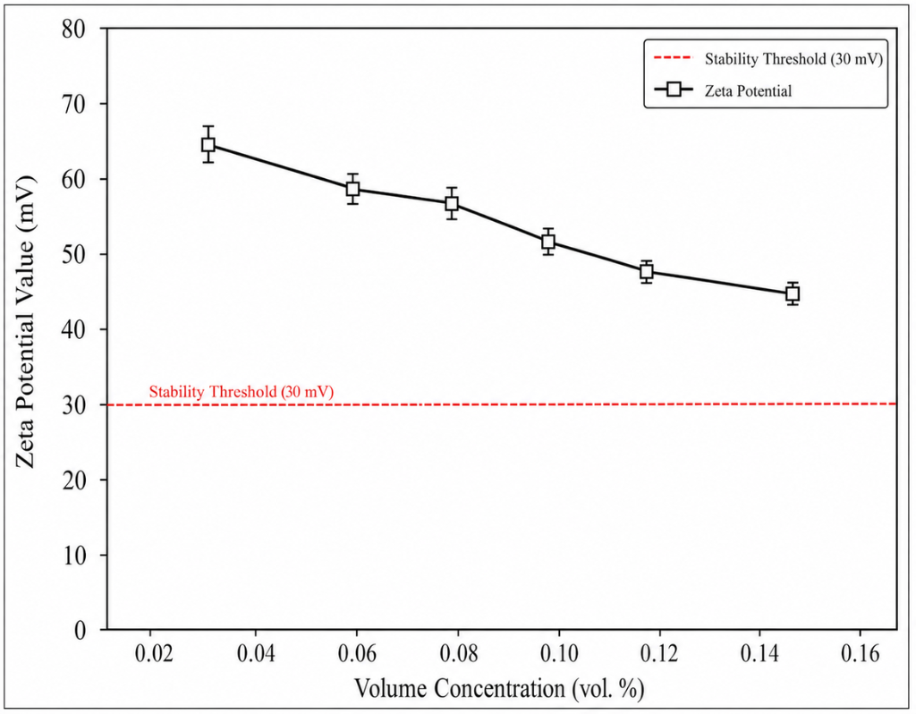
3.5 Abbreviations
All abbreviations should be defined when first introduced in the main text. A list of abbreviations may also be included at the end of the manuscript, after the references. Abbreviations in the abstract must be explained within the abstract itself, even if they are defined in the main text. Authors are strongly encouraged to use SI (International System of Units) units throughout the document. If other unit systems are used for disciplinary standards or to align with cited literature, the SI equivalent must also be provided.
3.6 Abbreviations and Units
All abbreviations should be defined when first introduced in the main text. A list of abbreviations may also be included at the end of the manuscript after the references. Abbreviations in the abstract must be explained within the abstract, even if they are defined in the main text. Authors are highly encouraged to use SI (Système International) units throughout the document. If other unit systems are used for disciplinary standards or to align with the cited literature, the SI equivalent must also be provided.
3.7 Supplementary Material
Supplementary material may consist of relevant data, extended datasets, video files, codes, or other supporting information that could disrupt the flow of the main text if included but is essential for completeness or reproducibility. All supplementary files must be ready for publication, as they will be published exactly as provided, without editorial changes. Previously published supplementary materials are not allowed. Each supplementary item must be cited in the main text and listed under 'Supporting Information' with a clear, descriptive title. Supplementary material that has been published is permanently linked to the article and cannot be altered or removed.
4. Results and Discussion
The Results and Discussion sections should be presented in separate subsections or a single subsection, whichever improves clarity. The results should be clear and precise, including measures of uncertainty, statistical significance and replication. The findings should be discussed in the context of the existing literature, with their relevance highlighted, any discrepancies and unexpected results addressed, and any limitations that may affect the findings detailed. Avoid excessive citation and re-description of previous work, but discuss and contextualise the new results.
5. Conclusions
The conclusions section should provide a concise summary of the main findings and their significance. It should directly address the objectives stated in the introduction, reaffirm the study's key findings, and outline the practical and theoretical implications of the results. It should not simply repeat the abstract or list the results, but instead synthesise and contextualise the findings with respect to the objective(s) and advances in knowledge in the field. Authors can also use the limitations or scope of the current study to raise unanswered questions or to identify potential directions for future research.
Acknowledgements
The Acknowledgements section should list all individuals who helped with the research or manuscript but do not meet the ICMJE authorship criteria. Contributions must be specified by name and type, such as statistical advice, lab support, or language editing. Each individual’s acknowledgement must be confirmed by them before submission. Funding sources are not to be included here but should be reported in the separate Funding subsection below. Any institutional contributions must also be acknowledged in this section.
Funding
Authors must disclose all financial and material support related to the research and manuscript. This includes grants, fellowships, publication fee assistance, in-kind contributions (e.g., equipment, materials, reagents, data tools), externally funded salaries, and travel or accommodation expenses. The section should be titled “Funding” and list the full official name of each funder, along with the corresponding grant or award number. The same details must be entered into the submission system’s funding metadata fields to ensure inclusion in the CrossMark record and in international funding registries. The corresponding author is responsible for ensuring that all funding disclosures are accurate, complete, and consistent across co-authors prior to submission.
- With Funding: 'This work was supported by [Source of funding body], including the [Type of grant] and [Grant number: xxxxx].' (Note: Detailed descriptions of the programmes, grants, or awards are not required.
- Without Funding: If no specific funding was available for the research, the following mandatory statement must be included: 'This study was not supported by any grants from funding bodies in the public, private, or not-for-profit sectors.'
Declaration of Competing Interests
A competing interest is any financial, professional, personal, or institutional connection that could influence the research. Disclosure ensures transparency, not an admission of bias. Authors must declare all relevant interests from the three years before the research, and any earlier ones that could still be perceived as a bias. Financial interests include employment, stocks or options, consultation fees, honoraria, paid expert testimony, royalties, and related patents in organisations with a stake in the outcome. Non-financial interests include unpaid leadership roles, relevant personal or professional relationships, and strongly held beliefs on the subject. These obligations extend to immediate family members. Authors with editorial or advisory roles at journal must notify the editorial office before submission and include a recusal statement in the Declaration of Competing Interests.
- With competing interests
Specify each author's individual interests clearly using the sub-heading 'Declaration of Competing Interests'.
- No competing interests
The authors declare no conflicts of interest OR
The authors declare no relevant financial or non-financial conflicts of interest OR
All authors certify that they have no affiliations with any organisation with a financial or non-financial interest in the subject matter of this manuscript'

CRediT Author Contribution Statement
The journal requires that every manuscript include a CRediT Author Contribution Statement using the 14 standardised NISO CRediT roles. This statement complements, but does not replace, the ICMJE authorship criteria; all named authors must still meet the four ICMJE requirements, with CRediT specifying each author's contribution. It appears below the Funding information and is submitted as structured metadata for accurate bibliometric attribution. The corresponding author must complete the statement in consultation with all co-authors and confirm their agreement before submission. Role assignments must reflect actual contributions; inflated, fabricated, or inaccurate assignments will be treated as authorship misconduct.
To ensure consistency, authors are recommended to adopt the following standard roles: Conceptualisation; Methodology; Validation; Analysis; Data curation; Investigation; Resources; Software; Visualisation; Writing – original draft; Writing – review & revise; Funding acquisition; Project administration; Supervision.

Example format:
N. A. Ahmad: Conceptualisation; Methodology; Analysis; Writing –Original draft
M. M. Rahman: Conceptualisation; Supervision; Writing –Review & revise; Funding acquisition
K. Kadirgama: Validation; Data curation; Project administration; Writing –Review & revise
S. Y. Lim: Investigation; Software; Visualisation; Writing –Review & revise

Availability of Data and Materials
To promote transparency and ensure reproducibility, authors must provide a clear statement regarding the accessibility of the data, materials, and source code utilised in the study. Authors are required to select and adapt one of the following standard statements as applicable:
- Available on request: The datasets generated and/or analysed during the current study are available from the corresponding author on reasonable request.
- Publicly available: The datasets generated and/or analysed during the current study are available in the [Repository Name] at [Persistent Link/DOI].
- Not applicable: Data sharing is not applicable to this article as no new datasets were generated or analysed in this study.

Ethics Statement
An ethics statement is required for all research involving human participants, animals, or sensitive personal data. For human participants, provide the ethics committee or IRB name, approval reference number, and approval date, and confirm adherence to the approved protocol and the Declaration of Helsinki (2013 revision) or relevant national guidelines. For animal studies, confirm compliance with applicable welfare laws and institutional policies, including the name of the approving committee, approval number, and date. For personal data, confirm compliance with the Malaysian Personal Data Protection Act 2010 and other relevant international privacy laws. If ethics review was waived (e.g., for publicly available secondary data or anonymised records), state the basis. The Editor-in-Chief may request ethics approval documents at any time during the review process.
All research must demonstrate strict compliance with institutional, national, and international ethical standards. Authors should select and adapt the most relevant statement from the examples below:

Human Data or Participation: The study was conducted in accordance with the Declaration of Helsinki and approved by [Name of Ethics Committee] (Approval No. [XXXX]; Approval body name, Approval Date: [DD/MM/YYYY]). Informed consent was obtained from all participants.

Animal Studies: All experimental procedures involving animals were approved by the [Institutional Animal Care and Use Committee Name] (Approval No. [XXXX]) and conducted in accordance with relevant national and international guidelines and regulations.

Simulation or Secondary Data Studies: This study did not involve human participants or animal subjects. Ethical approval was therefore not required for this research.
Generative Artificial Intelligence Disclosure
Authors must disclose any use of generative AI tools (e.g., large language models, AI writing assistants, image generators, or data analysis aids) during manuscript preparation, specifying the tool's name, version, and purpose of use. Authors remain fully responsible for the accuracy, originality, and integrity of all content; AI tools cannot be listed as authors as they do not meet ICMJE authorship criteria. Use of AI for language editing, grammar, or translation must also be declared. Undisclosed use of AI-generated text, figures, code, or references is a breach of journal publication ethics and will be handled under the journal’s Misconduct Handling Policy. If no AI tools were used, authors must state this explicitly.

Template Statements of AI Disclosure
No AI used: No generative artificial intelligence tools were used in the preparation of this manuscript. All intellectual content is original and solely attributable to the authors.

Language editing only: AI-based tools were used solely for language editing and grammar refinement. No AI content generation or data interpretation was performed. All intellectual contributions are original and solely attributable to the authors.

Extensive use: Artificial intelligence tools [specify tool and version] were used to assist in [specify: drafting, literature summarisation, data analysis, etc.]. All AI-generated content was reviewed and verified by the authors for accuracy and originality. Final interpretations and conclusions are the sole responsibility of the authors.

Example of References
Aguilera, R. V., Rupp, D. E., Williams, C. A., & Ganapathi, J. (2007). Putting the S back in corporate social responsibility: A multilevel theory of social change in organizations. Academy of Management Review, 32(3), 836–863. https://doi.org/10.5465/amr.2007.25275678
Christopher M. (2016). The agile supply chain. In J. Gattorna (Ed.), Handbook of Supply Chain Management (pp. 189–206). Routledge.
Hassan, R., & Lee, H. (2021, August 16–18). Digital twin adoption for production scheduling in discrete manufacturing [Paper presentation]. International Conference on Industrial Engineering and Operations Management (IEOM 2021), Kuala Lumpur, Malaysia. https://doi.org/10.1109/ieom.2021.00412
International Organization for Standardization (ISO). (2015). Quality management systems- Requirements (ISO Standard No. 9001:2015). https://www.iso.org/standard/62085.html
Olsen, W. P. (2010). The anti-corruption handbook: How to protect your business in the global marketplace. John Wiley & Sons.
Stadtler, H., & Kilger, C. (Eds.). (2015). Supply chain management and advanced planning: Concepts, models, software, and case studies (5th ed.). Springer. https://doi.org/10.1007/978-3-642-55309-7
Urmi, W. T. (2021). Total quality management practices and firm performance in Malaysian manufacturing SMEs [Doctoral dissertation, Universiti Malaysia Pahang Al-Sultan Abdullah]. UMPSA Institutional Repository. https://umpir.ump.edu.my/id/eprint/38210
World Bank. (2022). Global Economic Prospects: June 2022. World Bank Group. https://doi.org/10.1596/978-1-4648-1843-1
Zainal, A., Hassan, R., Ismail, N., Osman, K., Aziz, F., Rahim, S., et al. (2022). Industry 4.0 readiness across manufacturing sectors: A multi-firm survey. Production Planning and Systems, 34(6), 880–905. https://doi.org/10.1080/prod.2022.0345x

General Guidelines of References
Adherence to the APA 7th edition (author–date) citation style is mandatory at the submission stage. Authors must ensure that all references are prepared according to APA 7 guidelines and that consistency is maintained throughout the manuscript. Each reference entry must include the author(s)’ names, year of publication, title of the article or chapter, full journal or book title, volume number, issue number (if applicable), page range, and publisher details where relevant. The inclusion of a Digital Object Identifier (DOI) in URL format (https://doi.org/xxxxx) is highly encouraged for all applicable references. Please note that the journal's official formatting will be strictly applied during the proofing stage, and any missing metadata will be highlighted for mandatory correction by the author.
In-text citations and integration: All citations must be relevant, current, and appropriately integrated into the text using the author–date format. In-text citations must include the author’s surname and year of publication (e.g., Rahman, 2020). For direct quotations, the page number must also be included (e.g., Rahman, 2020, p. 25). For works with two authors, include both names (e.g., Rahman & Ali, 2021). For three or more authors, use the first author’s surname followed by “et al.” (e.g., Rahman et al., 2022). Multiple references within the same parentheses must be listed alphabetically and separated by semicolons (e.g., Ali, 2019; Rahman, 2020; Siti et al., 2021).
Reference Arrangement: References must be arranged alphabetically by the surname of the first author.
Journal Articles Format:
Author(s). (Year). Title of the article. Full Journal Title, Volume(Issue), page range. https://doi.org/xxxxx
Conference Papers Format:
Author(s). (Year). Title of the paper. In Editor(s) (Eds.), Title of the conference proceedings (pp. xx–xx). Publisher. https://doi.org/xxxxx (if available)
Citation Integrity and Self-Citation Policy: The journal upholds a strict policy against citation manipulation. Authors are required to minimise self-citations, which must not exceed 5 citations or 10% of the total number of references, whichever is lower. All citations must be academically justified and directly relevant to the study.

Citing References in Text
To maintain editorial consistency, please apply the following formats:
- Single Reference:
“…as demonstrated by Rahman (2020).” or “…as demonstrated in previous studies (Rahman, 2020).”
- Multiple References:
“…previous investigations (Ali, 2019; Rahman, 2020; Siti et al., 2021) have suggested…”
- Multiple Works by Same Author (Different Years):
“…recent studies (Rahman, 2018, 2020, 2022) indicate…”
- Citing a Specific Page (Direct Quote):
“…as stated by Rahman (2020, p. 25)…”

